**Neural Networks & Deep Learning Assignment 06 🡪ICP 06**

**Name: Azharuddin Mohammad**

**700#: 700756035**

**GitHub Link:** [**https://github.com/mohammadazharuddin982/NN-DL_ICP06_700756035_Azharuddin_Mohammad**](https://github.com/mohammadazharuddin982/NN-DL_ICP06_700756035_Azharuddin_Mohammad)

**Video Link:** [**https://vimeo.com/1018525511/1f9f0dc9d6?share=copy**](https://vimeo.com/1018525511/1f9f0dc9d6?share=copy)

**Question 01: Add one more hidden layer to autoencoder** 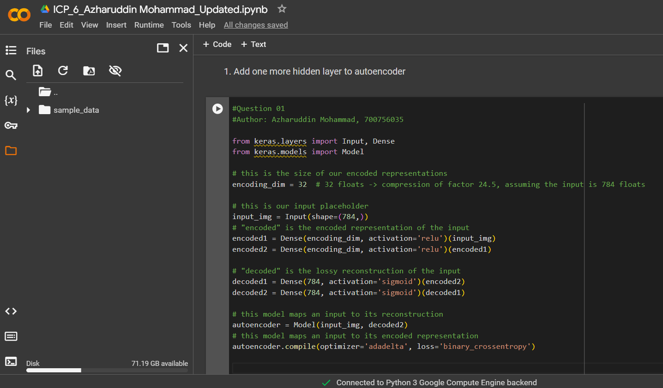

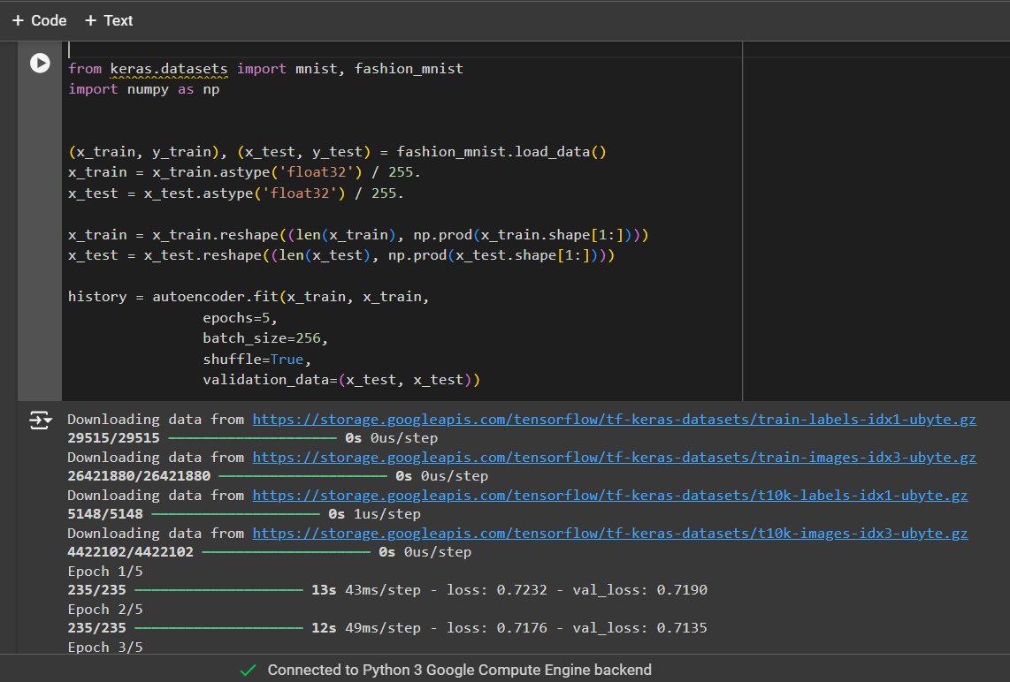

**2. Do the prediction on the test data and then visualize one of the reconstructed version of that test data. Also, visualize the same test data before reconstruction using Matplotlib** 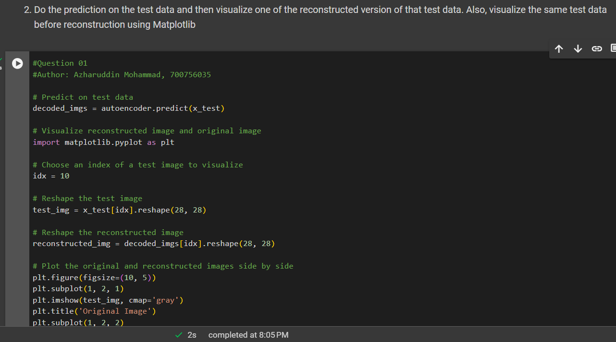

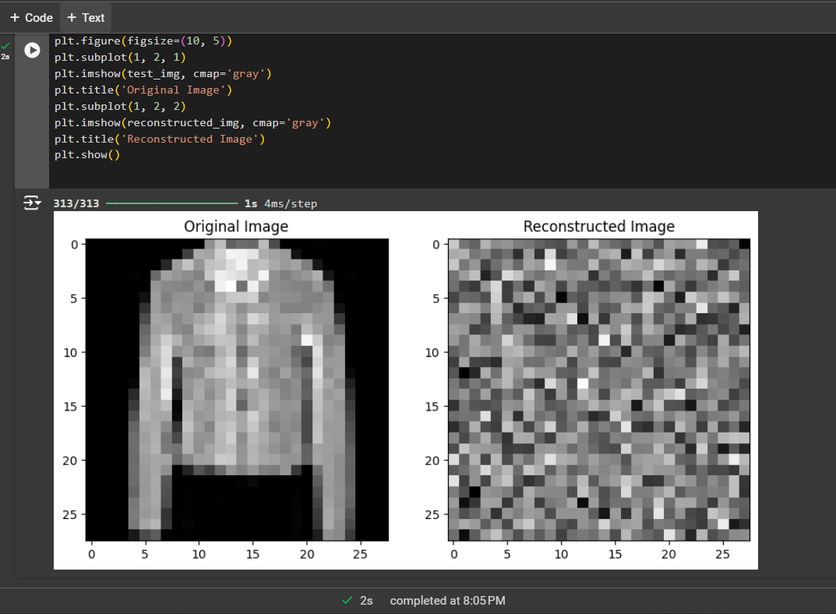

**3. Repeat the question 2 on the denoisening autoencoder**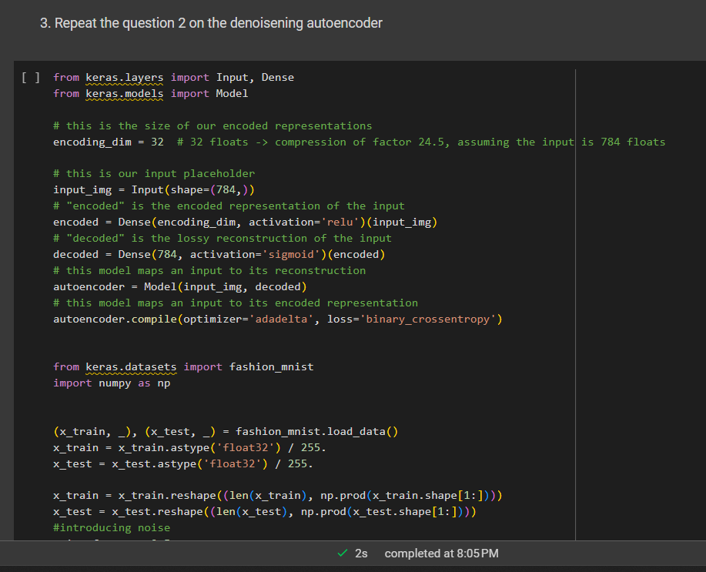

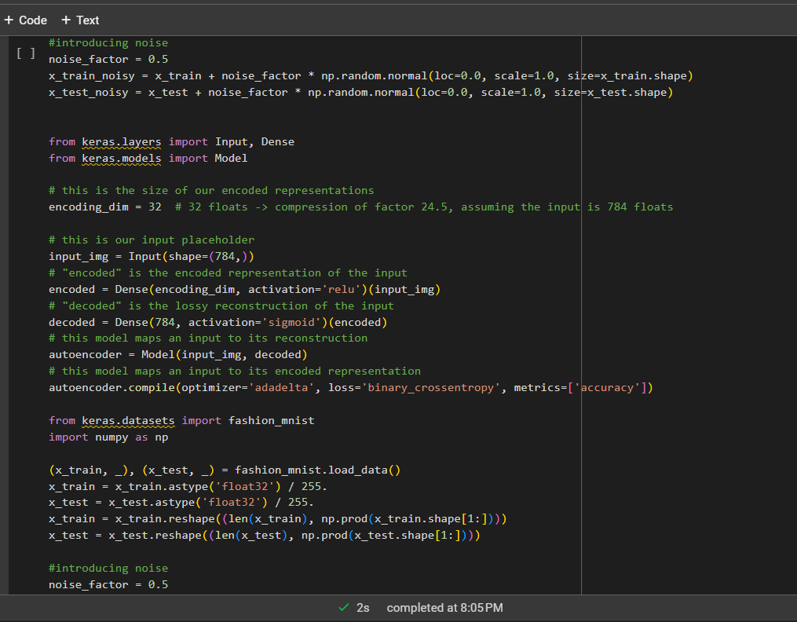

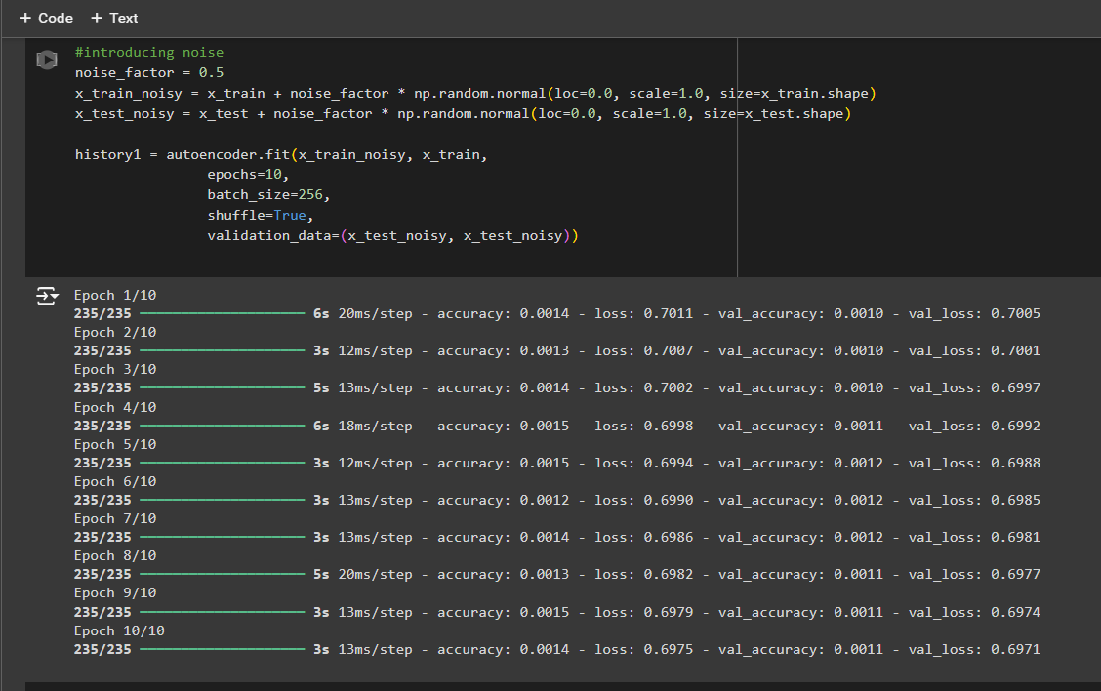

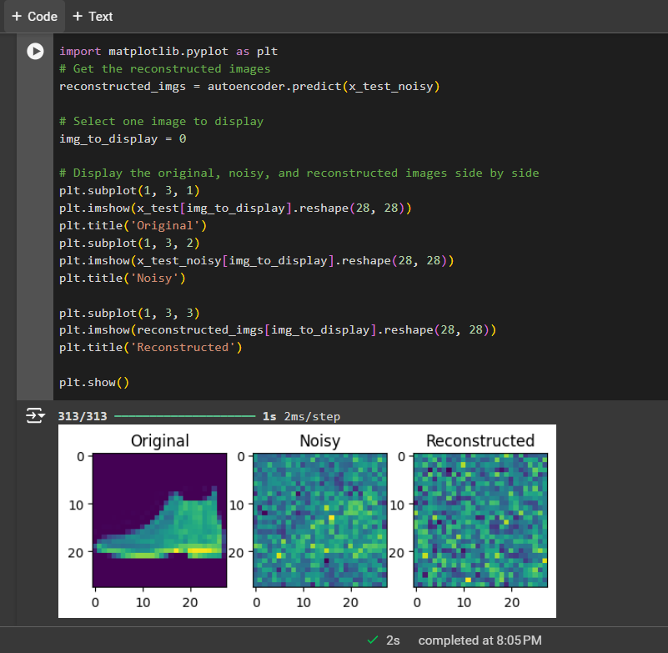

**4. plot loss and accuracy using the history object**